To calculate Annuitant’s pmt:

* Age, gender
* Payout option selected
* Life exp.
* Int rt.

Payout Option

* Straight Life - no beneficiary
* Period Certain
  + If client dies before period, then beneficiary gets $$
  + Else, beneficiary gets nothing
* Unit Refund Life - If the annuitant dies before an amount equal to the value of the annuity units is paid out, the remaining units will be paid to a designated beneficiary.
* Joint and Last Survivor - an option in which payments are made to two or more persons. If one person dies, the survivor continues to receive only her payments. However, upon the death of the last survivor, payments cease.

C11: Emma System

* EMMA = Electronic Muni Market Access (Rule G32)
* EMMA provides free public access to official statements, trade data, credit ratings, educational materials, and other information about the municipal securities market.
* EMMA presents the information in a manner that’s specifically tailored for retail, non-professional investors who may not be experts in financial or investing matters

C1:

UNIFORM SECURITIES ACT - provisions established by NASAA, primary purpose is to create rules, laws, and exam requirements for the states

Primary purpose of a depository facility is to hold securities in street name

The Depository Trust Corporation (DTC) is a subsidiary of the Depository Trust & Clearing Corporation (DTCC) and its primary function is to hold securities in book-entry form. - It is not a clearing facility

C7:

When an investor reinvests her dividends and/or interest distributions from a mutual fund, she's required to pay taxes in the year of the distribution. As a result, the reinvestments will add to her total cost basis. In this question, the total cost basis is $53,500 (i.e., $50,000 investment + $3,000 reinvested dividends + $500 reinvested interest).

C12: ORDERS AND TRADING STRATEGY

* Recognize and understand the function of brokers (agents) and dealers (principals) act and how they’re compensated:
  + Brokers/Agents - commission - separate $ amt noted on trade confirmation
  + Dealers/Principals/Market Makers - buys/sells securities for/from its own account, provides both bid and ask and earns from the spread, earns on the markup
* Understand the 5% policy and the factors that influence a firm’s commission or markup
  + Price, type, availability, pattern, disclosure, nature of the BD business
* Define the term proceeds transaction
  + When a customer directs a member firm to sell a sec and use the proceeds to buy another sec
  + Member firm should follow 5% markup policy
* Recognize and understand the different types of transactions (e.g., purchase, long sale, short sale)
  + Short sale requires margin account
* Understand the difference between a covered and uncovered option writer
  + Covered = owned shares before selling
  + Uncovered = didn’t own shares before selling
* Recognize and understand the various types of orders, including market; limit; buy limit; sell limit; and stop orders
  + 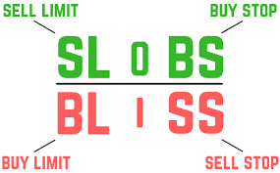
  + 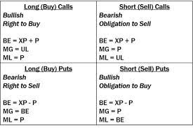
* Define the terms day order and good ‘til cancelled (GTC or open order)
  + Day order is the unless otherwise specified order, (9:30AM to 4pm ET), if not executed, is cancelled
  + GTC - remains in effect on BD’s order book until its either executed or cancelled, week, month, any specified time, if it runs out of time, it’s cancelled
* Identify the price and size of a market maker’s quote
* Understand the types of purchases and sales that can be executed in cash and/or margin accounts